Ridley JR ABA Account Creation User Guide

How to create your account and Register
1) Create an account. To create your account, you simply need to visit the new website at www.ridleyjraba.com and click on the Register / Login link in the top right hand corner.
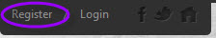
2) Fill out the New Customer Primary Contact section on the login screen. Then click Create new Account.
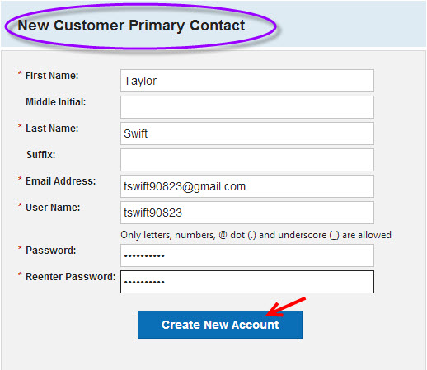
3) Fill out your Primary Contact Information section and then click Next.
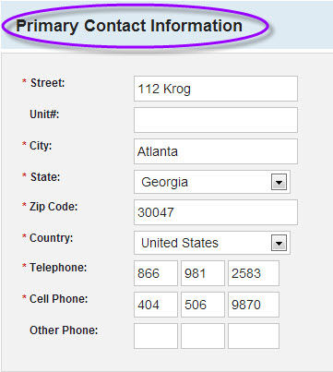
4) Fill out the Participant Information section and please make sure to fill out all information.
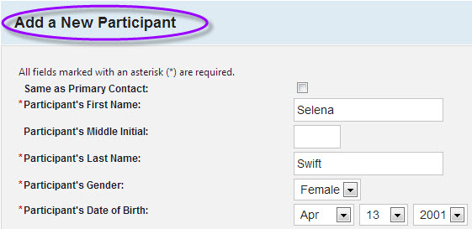
Once this is completed, you will then proceed to the registration process by selecting Available Programs. Please note, that depending on when you create your account, registration may not be open and programs may be unavailable. Please do not panic!! Once the registration is open, you will see all programs available for each child and follow the next steps.
5) Available Programs: Select the programs which you will want to register for by using the check box with the program name. (Please remember, if registration is not open, you will not see any programs)
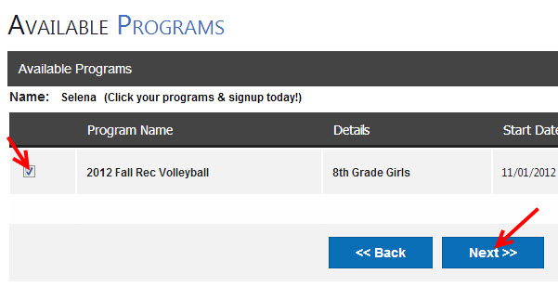

At this point, you will be taken to your shopping cart to view your registrations. Any family or player discounts that the ABA may have will automatically be deducted and applied to your registration. You will be able to print your confirmation well as receive a confirmation email which will be automatically generated for your records.

That is it!! You are all set.

